take the google doc with a few grains of salt, its just pondering and hypotheticals currently.
AI Compliance Training System

Architecture & Implementation Plan (Vidda Solutions)

1. Overview
We are building an AI-powered, human-in-the-loop system that generates customized compliance training programs for regulatory requirements.
The system has two core stages:
- Risk Intelligence Stage → identifies what compliance risks exist for a role
- Training Generation Stage → converts those risks into structured training content

2. Problem We Are Solving
Compliance training is typically:
- generic (not role-specific)
- manually created
- slow to update when regulations change
Our system solves this by:
- automatically identifying risks per job role
- generating tailored training programs
- allowing human compliance review before release

3. System Overview (High-Level)
User Input (Job Role / Description)
↓
────────────────────────────────────
PIPELINE 1: RISK INTELLIGENCE
────────────────────────────────────
↓
Risk Identification + Training Plan
↓
Human Review (optional / approval)
↓
Selected Risks for Training
↓
────────────────────────────────────
PIPELINE 2: TRAINING GENERATION
────────────────────────────────────
↓
AI-Generated Training Content
↓
Human Compliance Review
↓
Final Training Package (LMS / PDF / SCORM)

4. PIPELINE 1 — Risk Intelligence System (CURRENT SYSTEM)

Purpose
This system determines:
“What compliance risks exist for a given job role?”

Current Architecture
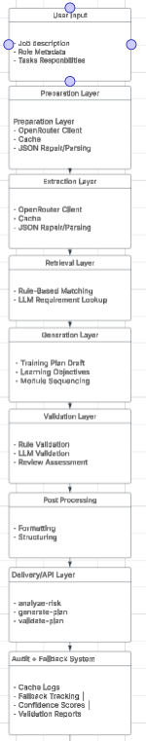

What This System Produces
- List of identified compliance risks
- Risk confidence scores
- Training plan (high-level structure)
- Initial learning objectives

What This System DOES NOT Do
- Does NOT generate actual training content
- Does NOT create lessons.
- Does NOT produce LMS-ready training modules

5. PIPELINE 2 — Training Generation System (TO BE BUILT)

Purpose
This system determines:
“How do we teach the identified risks?”

Input to this system
- Approved risks from Pipeline 1
- Optional user selection of which risks to train on

Proposed Architecture
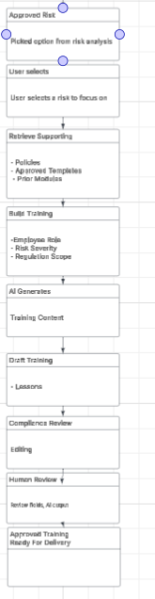

What This System Produces
- Full training modules per risk
- Lesson content
- Real-world scenarios
- Assessment structure
- Exportable training packages

6. Key System Relationship
It is important to understand how the two systems connect:

Pipeline 1 (Risk Intelligence)
Determines WHAT employees need to learn

Pipeline 2 (Training Generation)
Determines HOW employees learn it

7. End-to-End System Flow
User Input (Job Role / Description)
↓
PIPELINE 1: RISK INTELLIGENCE
↓
Identified Risks + Training Plan
↓
Human Review / Selection (optional gating step)
↓
PIPELINE 2: TRAINING GENERATION
↓
Generated Training Content
↓
Human Compliance Review
↓
Final Training Package (LMS / PDF / SCORM)

8. Human-in-the-Loop Design
Human review exists at two critical stages:

1. After Risk Identification
- ensures correctness of compliance interpretation
- allows approval of relevant risks only

2. After Training Generation
- ensures training content is legally accurate
- ensures tone and structure meet compliance standards

